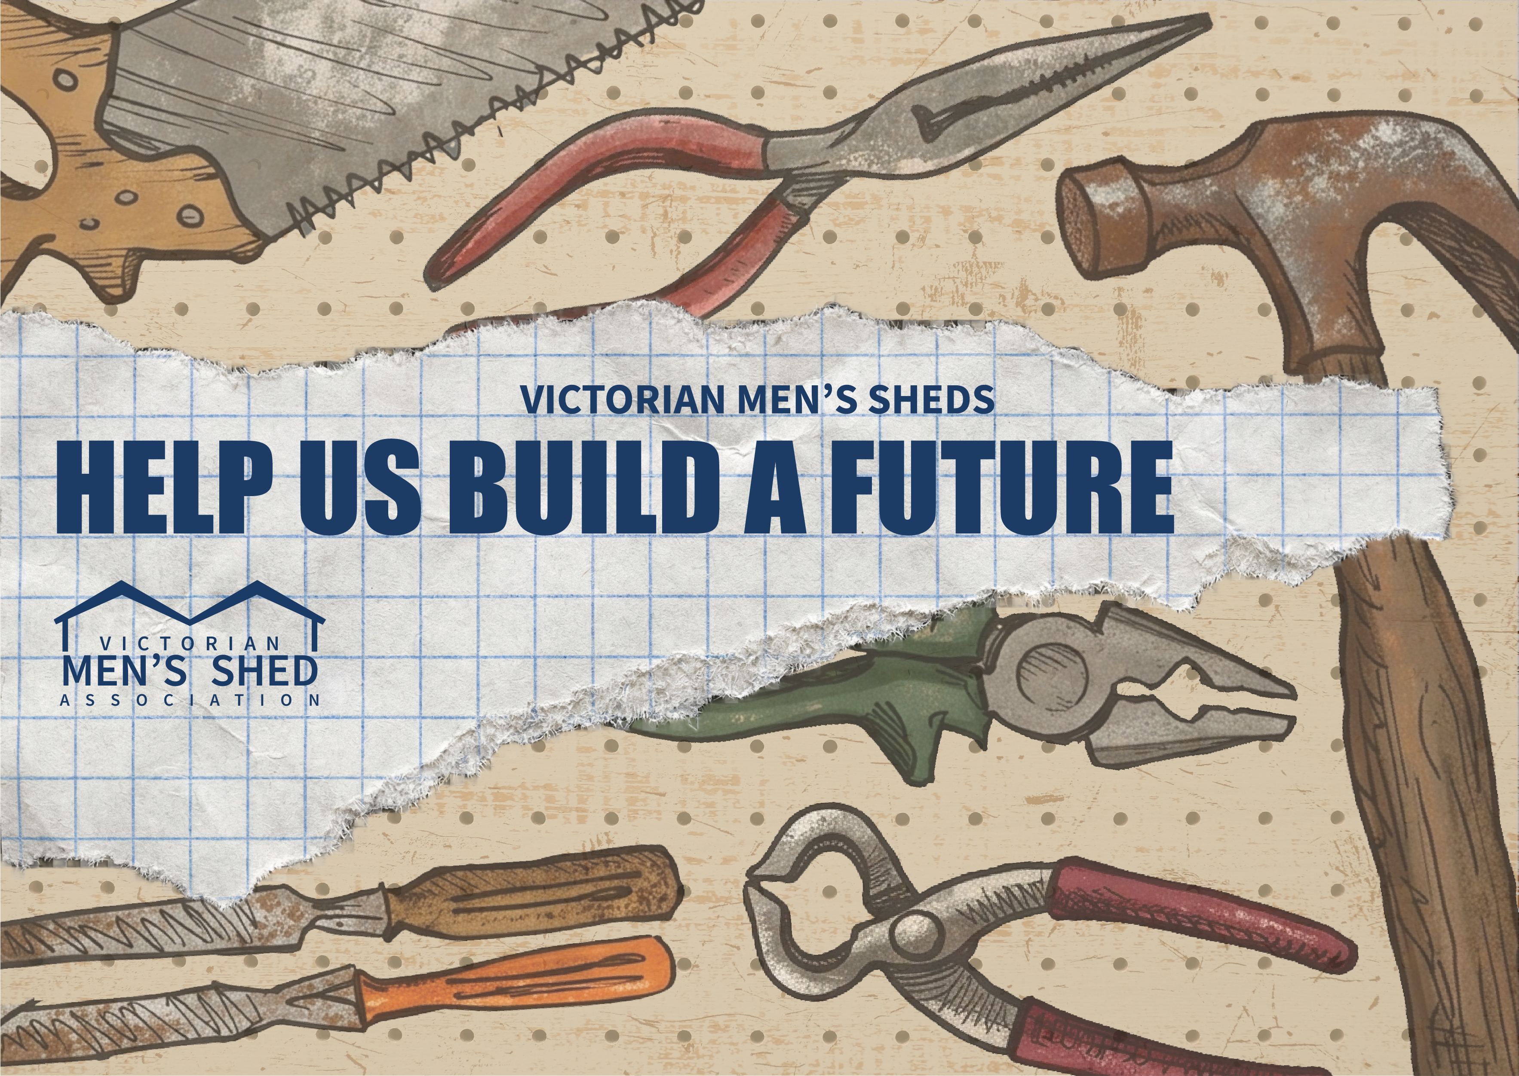

Email Your Members & Supporters
Use the resources below to email your members and supporters about the Help Us Build a Future campaign. Copy and paste the subject line and email body, attach the campaign image, and send it from your shed’s usual email address.

Email Subject Line
What to do | Detail
Instruction | Copy and paste the subject line below into the subject field of your email.
Subject line — copy & paste this text | Help us build a future for Victorian men’s sheds

Campaign Image
What to do | Detail
Step 1 | Download the campaign image attached to this document.
Step 2 | Attach the image to your email or insert it at the top of your email body before sending.

Email Body
What to do | Detail
Instruction | Copy and paste the email body below. Replace [Member/Supporter name], [Your name] and [Shed name] with your own details before sending.
Email body — copy & paste this text | Dear [Member/Supporter name],  We need your help to secure the future of men’s sheds in Victoria.  STRONGER MEN’S SHEDS MEAN STRONGER COMMUNITIES  Victoria’s men’s sheds deliver enormous health benefits and a huge social contribution to members and communities across the state.  INSUFFICIENT SUPPORT FOR MEN’S SHEDS  Men’s sheds have received the same amount of funding since 2012 but our network has tripled in size. Men’s sheds are underfunded and under-resourced.  WHAT’S NEEDED  Men’s sheds are calling for an increase in State Government funding from $1m to $3m per annum from 2027/28 with ongoing indexation.  HOW YOU CAN HELP  Your support will help men’s sheds grow and secure their future. Please add your name to our e-postcard or pick up a hard copy form at the shed.  Add your name today: www.vmsa.org.au/help-us-build-a-future  Thank you for your support.  [Your name]  [Shed name]

www.vmsa.org.au/help-us-build-a-future

