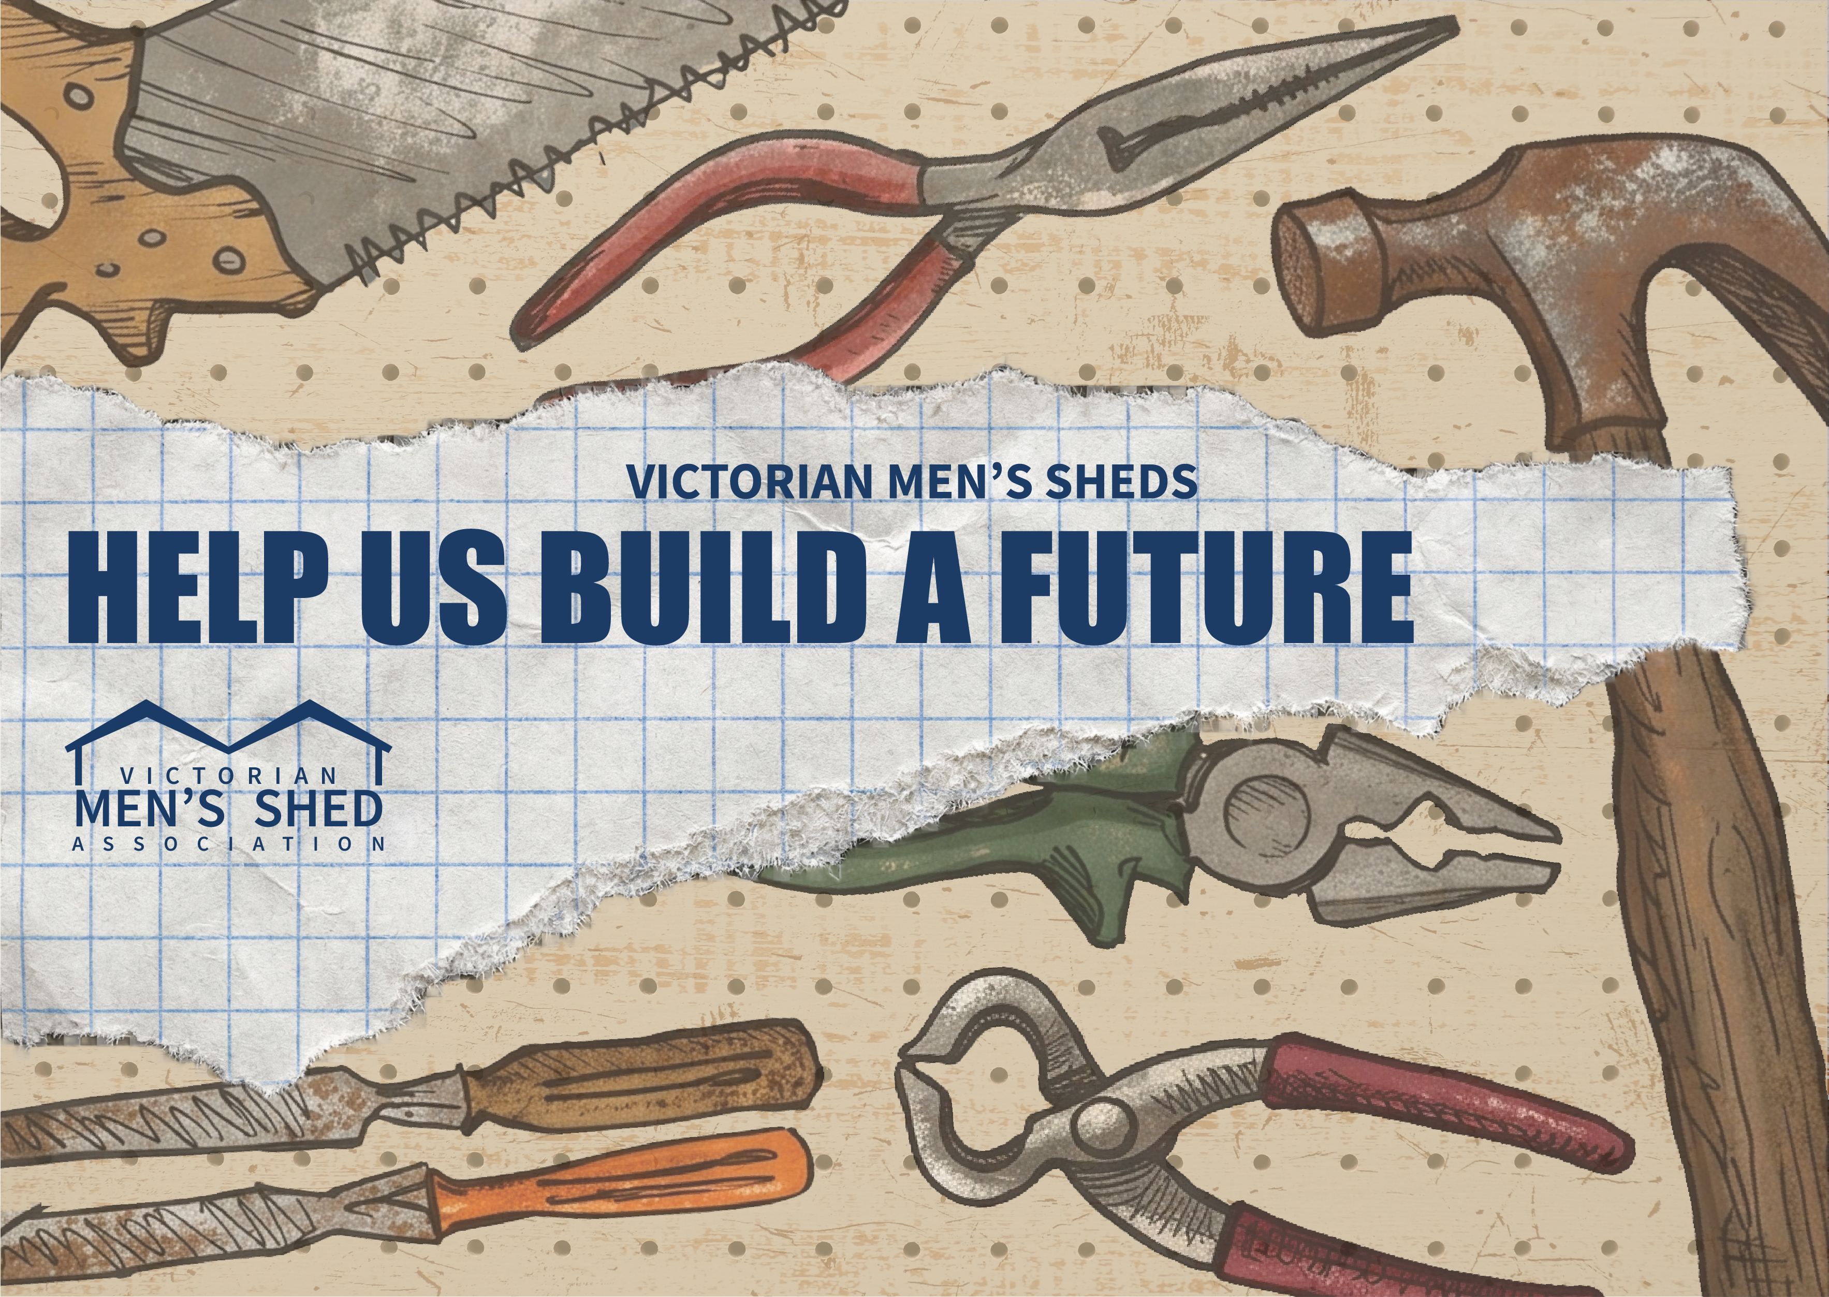

How to Use These Resources
Use the tables below to share the campaign on social media. Save the image and copy the caption text directly into your post.

Campaign Image
What to do | Detail
Step 1 | Download the campaign image attached to this document.
Step 2 | When creating your Facebook or Instagram post, attach the image before publishing.
Alt text | Adding alt text makes your post accessible to people using screen readers. When uploading the image, paste the following into the alt text field:  “A collection of illustrated hand tools on a worn pegboard background. Text reads: Victorian Men’s Sheds — Help Us Build a Future.”

Facebook & Instagram Caption
What to do | Detail
Instruction | Copy and paste the text below directly into your Facebook or Instagram post as the caption.
Caption — copy & paste this text | STRONGER MEN’S SHEDS MEAN STRONGER COMMUNITIES  Victoria’s men’s sheds deliver enormous health benefits and a huge social contribution to members and communities across the state.  INSUFFICIENT SUPPORT FOR MEN’S SHEDS  Men’s sheds have received the same amount of funding since 2012 but our network has tripled in size.  Men’s sheds are underfunded and under-resourced.  WHAT’S NEEDED  Men’s sheds are calling for an increase in State Government funding from $1m to $3m per annum from 2027/28 with ongoing indexation.  HOW YOU CAN HELP  Your support will help men’s sheds grow and secure their future.  Visit our website or contact your local men’s shed to share your support on our e-postcard or put your name on a form.  Add your name today: www.vmsa.org.au/help-us-build-a-future

www.vmsa.org.au/help-us-build-a-future

