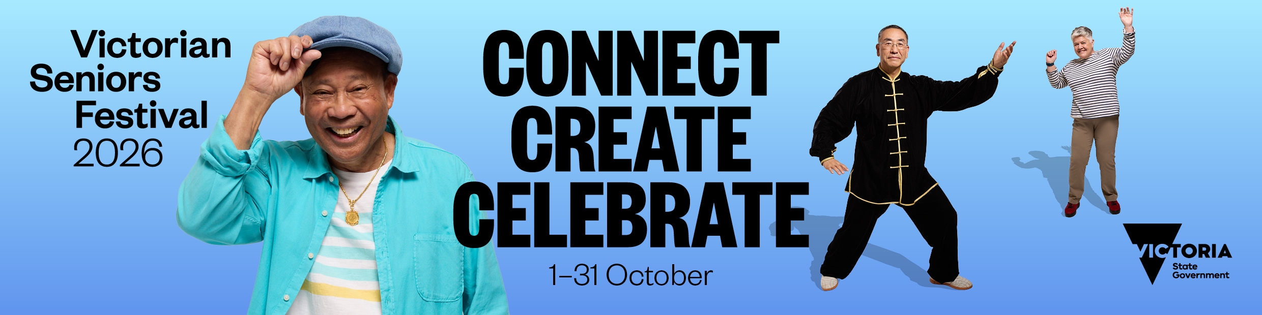

Guide to listing an event on the 2026 Victorian Seniors Festival online event calendar
OFFICIAL
Contents
About the online event calendar 2
Contact 2
Design assets 2
Key dates 2
Listing an event or activity 3
Submission criteria 3
Step 1: Open the submission form 3
Step 2: Complete the required fields 3
Step 3: After event submission 6
Making changes to your event 6
Submit an image for your event page 6
Using the multiple event date feature 7
Example 1: An event occurring on the one day, but at different times 7
Example 2: An event occurring on different days and at different times 9
Example 3: An event occurring on different days but at the same time 11

About the online event calendar
The Victorian Seniors Festival (the festival) is a major state-wide festival for and involving seniors which runs from 1 to 31 of October annually. The festival is delivered in collaboration with all 79 local councils, libraries, Neighbourhood Houses, community groups and sporting clubs.
The online event calendar is hosted on Seniors Online and used as a tool to promote thousands of events and activities from across Victoria.
All stakeholders are encouraged to list events on the calendar as it is promoted heavily to all Seniors Card holders.

Contact
If you have a question about the calendar, contact the Seniors Festival team via:
- phone: (03) 8850 6164
- email: seniorsfestival@dffh.vic.gov.au.

Design assets
Design assets are available to help you promote your Victorian Seniors Festival events and activities. Download the promotional toolkit including design assets via Dropbox.
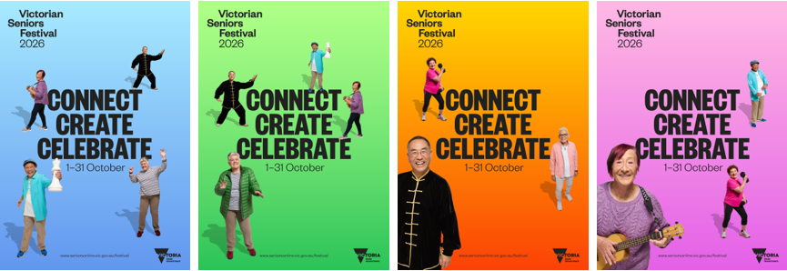

Key dates
Activity | Date 2026 | Time
Online event calendar opens for submission | Monday 25 May | 12:00 pm
Online event calendar closes for submission | Sunday 16 August | Midnight
Deadline to request changes for your submitted events | Monday 17 August, 5:00 pm | 5:00 pm
Online event calendar published on Seniors Online | Tuesday 1 September | By 5:00 pm
Note: Extensions will not be granted for late submission requests due to the volume of events that need to be processed prior to the publishing.

Listing an event or activity

Submission criteria
For an event or activity to be published on the calendar it must:
- take place in October 2026
- be free or low cost
- offer good quality entertainment in a friendly, inclusive environment
- offer people an opportunity to try something new.
Submissions cannot include special offers or business discounts for older Victorians. To offer discounts, please join the Victorian Seniors Card program. Information on becoming a participating business is available on Seniors Online.
Incomplete forms, or submissions provided in capital letters, are not eligible for publishing.
The Department of Families, Fairness and Housing reserves the right to edit or decline any event submitted.

Step 1: Open the submission form
The submission form is available on Seniors Online

Step 2: Complete the required fields

Event contact information
This field asks for the contact information that event attendees will use to arrange bookings or ask questions. This information will feature on the online event calendar and be made publicly available.
For this section you will need:
- Contact name
- Contact phone number: enter a 10-digit number without spaces or any other characters. Example: 0312345678, 0412345678, 1300123456
- Contact email
- Event website: the event website must be live prior to 9:00 am, Tuesday 1 September 2026

Event information
- Event name: Be specific and avoid titles that are general in nature such as ‘Seniors Festival music event’. Examples:
  - Abseiling adventure
  - Poi Twirling
  - All Access Sports Day
  - Cooking for Blokes
- Event type: in person or online
- Event category: select the category that best fits your events or activity.

Add date and time
- Start date
- Start time: required in 24-hour time, the format is hh:mm, where hh is hour and mm is minutes. Example: for an event starting at 2:00 pm you would enter, 14:00.
- End date
- End time: required in 24-hour time.

Add more dates
If your event occurs on multiple occasions, you can provide this information in a single submission.
Once you have included the date and start/end time for the first occurrence of your event you will be offered an Add more dates option.
If you check the box to confirm yes, another prompt will ask: How many more dates do you want to add?
You can add a minimum of 1 more date/time or a maximum of 15 extra dates/times, this covers:
- an event occurring on the same day, but at different times see example 1 below
- an event occurring on different days and at times see example 2 below
- an event occurring on different days but at the same time see example 3 below
If your event occurs on more than 16 occasions, split it into two listings: the first for your initial 16 dates and the second for the rest.

Short event description
This is a promotional blurb that appears on the list and map view with the event. The character limit is 100 for this section. Focus on key information you need to communicate to event attendees and avoid repeating the venue, event name or location as this will appear separately.
Examples:
- Come and chat with friends old and new, while Councillors serve you delicious treats.
- Join us for a guided tour and cultural experience. Learn about the Sikh religion and culture, followed by a free meal.
- Older Victorians their friends, allies are invited for a day full of entertainment. Enjoy music, dance and workshops.

Long event description
This is the detailed description that will show on the individual event page. This may include what attendees can expect, who is performing, booking deadlines, and what to bring. Following on from the examples above:
- The Council Chambers are being transformed! Come and chat with friends old and new, while Councillors serve you delicious treats. Help us celebrate the start of Seniors Festival 2026! Book your ticket online by 28 September.
- Join us for a guided tour and cultural experience. Learn about the Sikh religion and culture, followed by an enjoyable free vegetarian meal. Please bring your own head scarf or one will be provided if needed. Shoes are not permitted inside, so please wear socks. Bookings are essential
- Come join in a celebration of older Victorians, their friends, allies and families. Celebration Day welcomes and encourages all to enjoy and engage in wonderful performances. The Fed Square precinct will come to life with entertainment featuring mainly older artists. Enjoy music, dance and workshops across the Main Square, Birrarung Marr Stage and Zinc Studio.

Venue address
This calendar includes a map feature which only works if you provide specific address information.
Make sure you include the building or venue name (example: Town Hall) and street number.
This is a required field for all in person events.
For this section you will need:
- Street address, example: Melbourne Town Hall
- Street address line 2, example: 27 Fisher Street
- Suburb
- State
- Postcode

Cost
Victorian Seniors Festival events are required to be free or low cost.
The options available in the form include:
- Free
- Gold coin donation
- Cost of the event tickets based on a dollar value, example: $10

Inclusions
Enter any event inclusions and details about whether your event is accessible. For example: Morning tea starts at 10:00 am and is included in the ticket price. This event is accessible for people with disability.

About you
Information provided here is for administrative purposes only. It’s used by the Seniors Festival team so you can be contacted if event information needs to be clarified before publishing.
This information is not published on your event listing or made publicly available.
For this section you will need:
- First name
- Last name
- Title
- Organisation
- Contact email address
- Confirm email address
- Phone number: enter a 10-digit number without spaces or any other characters. Example; 0312345678, 0412345678, 1300123456.

Submit your event
Once you have completed all the information, and checked everything included is correct, click the submit button shown.

Step 3: After event submission
After you click submit you can either list another event or close the window to exit.
You will automatically receive a confirmation email to the address entered in the about you section, which includes:
- A summary of all the information you have provided, exactly as submitted
- An event submission number. Example: #3229

Making changes to your event
Review your confirmation email. If you spot any errors, email the Seniors Festival team at seniorsfestival@dffh.vic.gov.au with your requested changes and the event submission number in the subject line.
Changes can be requested until Monday 17 August at 5:00 pm.
Any requests made following this deadline are not guaranteed.

Submit an image for your event page
To include an image with your event, email it to the Seniors Festival team at seniorsfestival@dffh.vic.gov.au. Include your event name and event ID in the subject line.
The image must:
- be 580px wide x 340px high
- be supplied as a .jpg or .png file
- not include any text, logos or booking information. For example, it cannot be a promotional poster.
Any images that do not meet the above specifications will be replaced with a stock image.
By providing an image with your event, you confirm that you have consent and copyright authority to share the images supplied.

Using the multiple event date feature

Example 1: An event occurring on the one day, but at different times
Cooking class that runs on 1 October at 10:00 am, 12:00 pm and at 3:00 pm.

Example 1, step 1: Enter the first occurrence of the event
For this example it will be 1 October at 10:00 am. We are assuming the session runs for 1 hour so ends at 11:00 am.
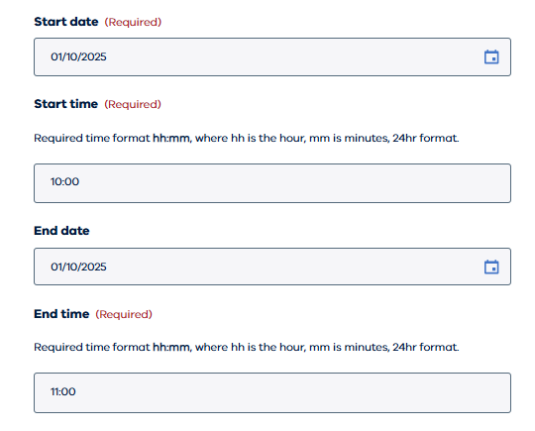

Example 1, step 2: Tick the box to confirm your event has more dates
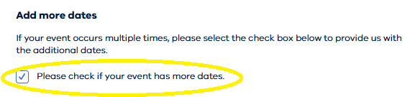

Example 1, step 3: Enter the quantity of additional sessions that are running on that date.
- In our example here that would be 2, as the session is already listed for 10:00 am, so we need to complete the information for the 12:00 pm and 3:00 pm session.
- Extra fields will appear on your screen for these 2 sessions to be included.
- Don’t forget the form is set-in 24-hour time!
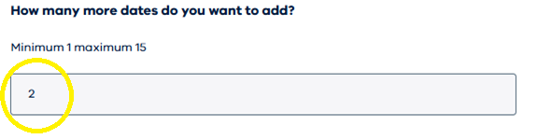

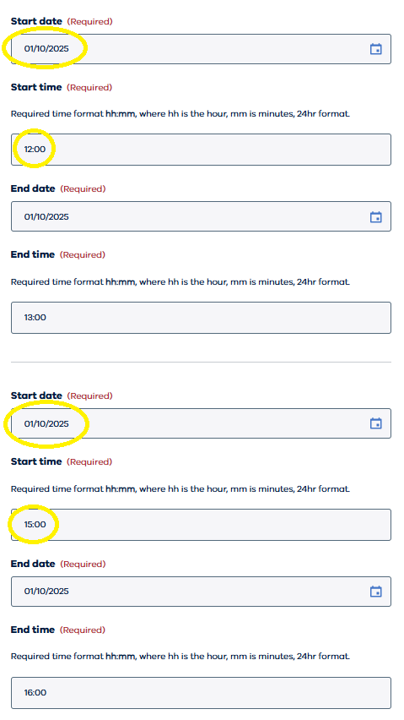

Example 2: An event occurring on different days and at different times
Art class that runs on 5 October at 10:00 am, 8 October at 11:00 am and 16 October at 2:00 pm.

Example 2, step 1: Enter the first occurrence of the event
In this case it would be 5 October at 10:00 am. We are assuming the session runs for 1 hour so ends at 11:00 am.
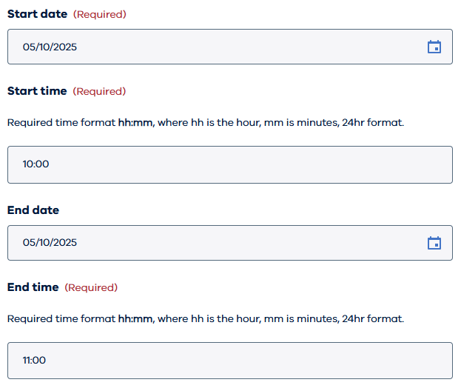

Example 2, step 2: Tick the box to confirm your event has more dates

Example 2, step 3: Enter the quantity of additional sessions that are running on that date
- In our example here that would be 2, as the session is already listed for 10:00 am, so we need to complete the information for the 11:00 am and 2:00 pm session.
- Extra fields will appear on your screen for these 2 sessions to be included.
- Don’t forget the form is set-in 24-hour time!
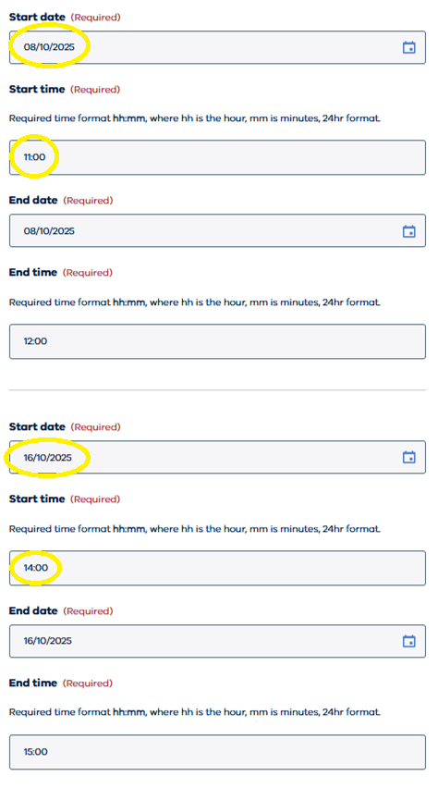

Example 3: An event occurring on different days but at the same time
Technology skills class that runs every day in the first week of October at 10:00 am.

Example 3, step 1: Enter the first occurrence of the event
In this case it would be 6 October at 10:00 am. We are assuming the session runs for 1 hour so ends at 11:00 am.
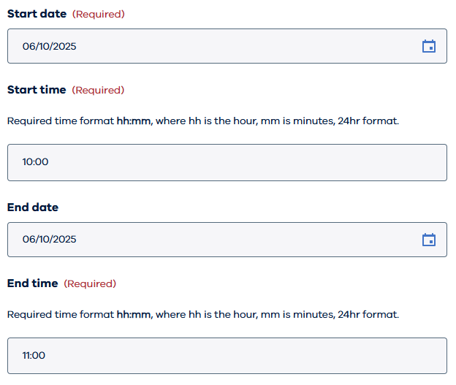

Example 3, step 2: Tick the box to confirm your event has more dates.

Example 3, step 3: Enter the quantity of additional sessions that are running on that date.
- In our example here that would be 6 more, as the session is already listed for 6 October at 10:00 am so we need to complete the information for 7, 8, 9, 10, 11 and 12 October at 10:00 am.
- Extra fields will appear on your screen for these 6 sessions to be included.
- Don’t forget the form is set-in 24-hour time!
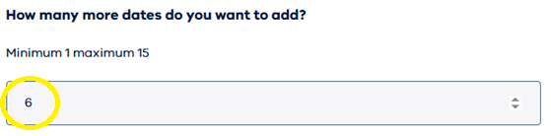

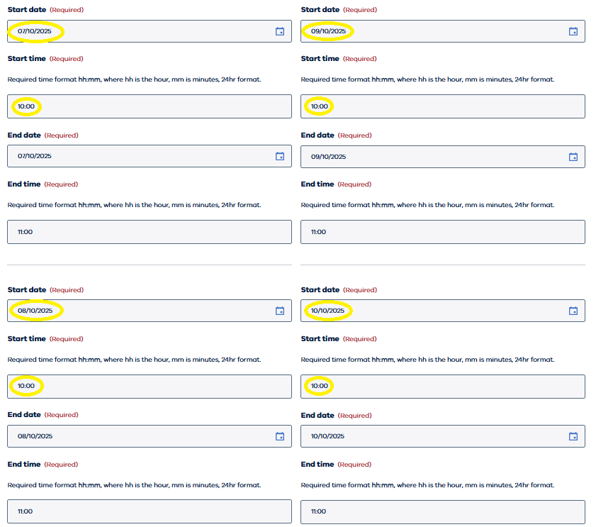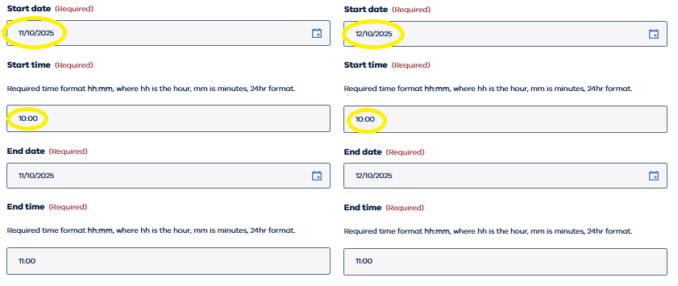

Contact us to receive this document in another format. Please phone the Victorian Seniors Festival team on (03) 8850 6164, or email seniorsfestival@dffh.vic.gov.au
If you are d/Deaf, hard of hearing, or have a speech/communication difficulty please contact us through your preferred National Relay Service (NRS) call channel Then, provide the NRS with our phone number (03) 8850 6164. For more information, visit About the National Relay Service
Authorised and published by the Victorian Government, 1 Treasury Place, Melbourne.
© State of Victoria, Australia, Department of Families, Fairness and Housing, May 2026.

https://www.seniorsonline.vic.gov.au/victorian-seniors-festival-event-submission
https://www.accesshub.gov.au/about-the-nrs/nrs-call-numbers-and-links
https://www.accesshub.gov.au/about-the-nrs

