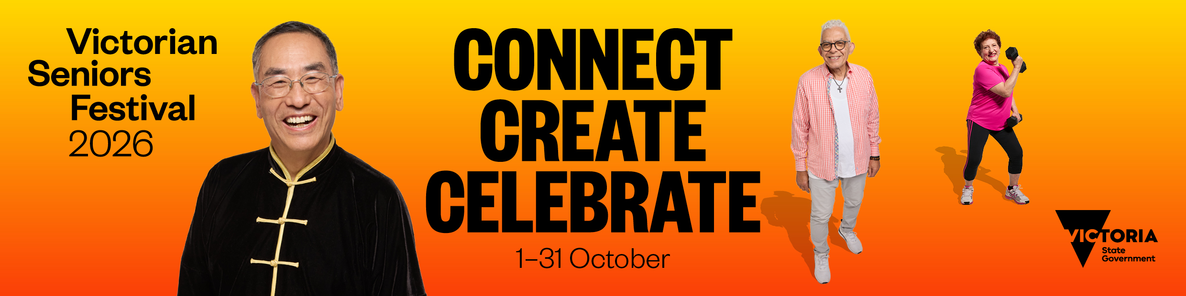

2026 Victorian Seniors Festival stakeholder promotional toolkit

OFFICIAL
Contents
About the festival 2
Contact 2
Communications materials 2
Key messages 2
Translated information 3
Newsletter or website copy 3
Social media 4
Design assets and brand guide 5
Design assets 5
Typography 7
Colour palette 9
QR Code 9
Photography 10
Digital assets 11
Print assets 12

About the festival
The Victorian Seniors Festival creates opportunities for Victorians who are 60 years and over to participate in fun, free and low-cost events throughout October. The festival encourages active ageing, community participation and meaningful social interaction.
This annual festival returns in October 2026, featuring:
- Live and local events across the state, delivered by local councils, community groups and clubs.
- Nine days of free public transport for Victorian Seniors Card holders from 3 to 11 October 2026.
- Flagship events held in Melbourne’s CBD and regional Victoria including:
  - Celebration Day at Federation Square on Saturday 3 October, 11 am to 5 pm. This event will launch the festival with hours of free entertainment and activities for older Victorians, their friends and families.
  - Big Band Dance at Melbourne Town Hall on Monday 5 October from 12 pm to 3 pm.
  - ACMI Seniors Film Festival at the Australian Centre for the Moving Image from 5 to 11 October.
- Country Concert Tour delivering live entertainment across regional towns in October.
- Aged Care Tour, taking the magic, music and fun of the festival to aged care residents across Victoria.

Contact
If you have a question about the festival, contact the Seniors Festival team via:
- (03) 8850 6164
- seniorsfestival@dffh.vic.gov.au

Communications materials

Key messages

General
- Connect, create and celebrate with the 2026 Victorian Seniors Festival. Get involved!
- Join in the fun this October and find a Victorian Seniors Festival event near you:
  - Visit Seniors Online: www.seniorsonline.vic.gov.au/festival
  - Check Seniors Online for which Coles, libraries and Neighbourhood Houses you can collect a festival guide from, starting 1 September
- Celebrate positive ageing and take part in events and activities close to home and right across the state.
  - The festival delivers a range of free and low-cost events for older Victorians.
  - Older Victorians can explore their interests or try something new.
- Victorian Seniors Card holders can access 9 days of free public transport across Victoria from 3 to 11 October 2026.
  - This includes travel across all metropolitan services, V/Line train and coach services, and selected regional bus services outside of the myki-enabled area.
- #VicSeniorsFestival

2026 theme – Connect, Create, Celebrate
- Come together, discover new interests and celebrate at the Victorian Seniors Festival.
- Connect
  - The Victorian Seniors Festival builds social, cultural and community connections.
  - Connect or re-connect with your interests, skills and hobbies.
  - Join in events and meet new people in-person and online.
- Create
  - Discover new interests and explore your creativity at the Victorian Seniors Festival.
  - Create your own path and remain curious as you age.
  - Join in events to build practical skills, make friendships and new social connections.
- Celebrate
  - The Victorian Seniors Festival celebrates the diversity of older Victorians.
  - Celebrate positive ageing.
  - Get involved, have fun and share joy.

Translated information
Information about the Victorian Seniors Festival translated into 16 languages is available on Seniors Online www.seniorsonline.vic.gov.au/translations

Newsletter or website copy
Download newsletter and web banners in Digital assets section of this pack.

Connect, create and celebrate at the Victorian Seniors Festival
The Victorian Seniors Festival returns this October with thousands of free and low-cost events for older Victorians across the state.
Celebrate positive ageing and take part in events and activities close to home and right across the state. The Victorian Seniors Festival encourages everyone to get involved, have fun and share joy.
The festival's theme – Connect, Create, Celebrate – invites older Victorians to come together, discover new interests and celebrate.
Connect or re-connect with your interests, skills and hobbies. Join in events and meet new people in-person and online.
Create your own path and remain curious as you age. Join in events to build practical skills, make friendships and new social connections.
Celebrate positive ageing. The festival delivers events and activities that celebrate the diversity of all older Victorians by supporting accessibility and inclusion.
Victorian Seniors Card holders can also enjoy 9 days of free public transport across Victoria from 3 to 11 October 2026. This includes all metropolitan public transport services, V/Line train and coach services, and selected regional bus services outside the myki area.
The Country Concert series returns to bring live entertainment to regional Victoria. While the popular Aged Care Tour will bring the magic, music and fun of the festival to aged care residents across the state.
The Victorian Seniors Festival is proudly supported by local councils, community groups and organisations across the state.
Join in the fun this October and find a Victorian Seniors Festival event near you:
- Visit Seniors Online to view the online event calendar: www.seniorsonline.vic.gov.au/festival
- Check Seniors Online for which Coles, libraries and Neighbourhood Houses you can collect a festival guide from, starting 1 September.

Social media
See the full range social media design assets in Digital assets section of this pack.

Department of Families, Fairness and Housing (DFFH) social media accounts to follow or tag
- Facebook: https://www.facebook.com/VicGovDFFH
- Instagram: https://www.instagram.com/vicgovdffh
- LinkedIn: https://www.linkedin.com/company/vicgovdffh
- Hashtag #VicSeniorsFestival

Suggested post text to combine with an image
Connect, create and celebrate at the #VicSeniorsFestival this October. Celebrate positive ageing and take part in events and activities close to home and right across the state.
🎉 Enjoy a range of free and low-cost events
🎨 Explore your interests or try something new
🚆 Access 9 days of free public transport across Victoria from 3 to 11 October 2026
To check out what’s on, visit www.seniorsonline.vic.gov.au/festival

Design assets and brand guide
The following design assets and brand guide are applicable for use to promote the 2026 Victorian Seniors Festival only. The assets and images cannot be used for promotion of future years or for any purpose other than the 2026 Victorian Seniors Festival.

Design assets
All design assets for 2026 can be downloaded from Dropbox
Individual assets are also linked in each section below should you only require individual items.
Artwork is available in high and low resolution.

Brandmark
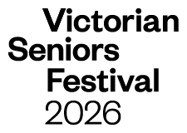
Victorian Seniors Festival 2026

Guidance for use
The Victorian Seniors Festival brandmark is a visible and valuable brand asset and should serve as the foundation for all visual communications. It is important that the brandmark is always applied consistently.
The brandmark will always be supplied in master form and should never be reconstructed or redrawn.
The brandmark is always reproduced in black. This allows effective contrast when used in combination with the festival brand colours.
Clear space: Clear space refers to the minimum surface surrounding the brandmark. This area must remain free of any other graphic elements and or text. Where possible, maintain more clear space around the brandmark than the minimum size specified.
Minimum clear space: To maintain the clarity, integrity and legibility an area of clear space around the brandmark should be maintained, no less than the height and width of the ‘V in 'Victorian'. This area must remain free of any other graphic elements and or text. Where possible, maintain more clear space around the brandmark than the minimum size specified.
Minimum size: The minimum recommended sizes for print applications is 15mm H and for digital applications it is 45px H. The brandmark should not be reproduced any smaller than 15mm H.

Tagline and co-branding
The supporting tagline and theme for the Victorian Seniors Festival 2026 is available to use in combination with the brandmark as shown here. Please do not use the tagline in capital letters in body copy of your communications to ensure accessibility.
Brandmark, theme and Victorian Government logo
Download brandmark from Dropbox.
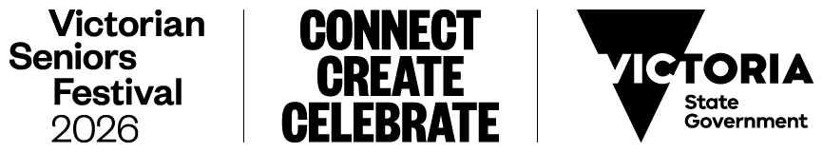
Co-branding with your logo
Download co-branding logo from Dropbox.
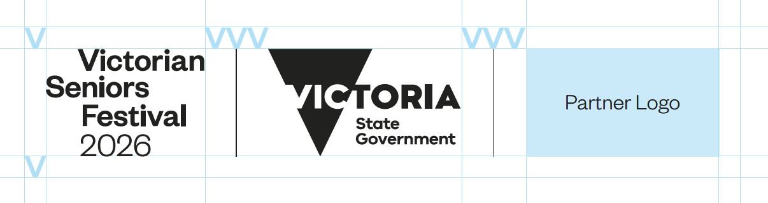
When the brandmark is required to be in a lock-up with other partner logos, please adhere to the following recommendations and use the V to calculate clear space required. Please ensure the dividing line is 1pt and 0.5pt at minimum size.
Clear space: The space around the block should be no less than the height and width of the V in Victorian. Where possible, maintain more clear space around the brandmark than the minimum size specified.
Clear space – multiple partners: The space around the blocks should be no less than the height and width of the V in Victorian.

EPS brandmarks for print
EPS brandmarks are available to download EPS brandmark from Dropbox.

Incorrect use
The Victorian Seniors Festival brandmark should never be altered. Protecting the brandmark means always ensuring that it is represented consistently and accurately. Electronic versions are available. The brandmark should never be redrawn or recreated digitally.

Typography

VIC
VIC is the brand font to be used across all communications alongside the Victorian Seniors Festival brandmark. VIC is used in sentence case only, when not being used for display purposes.
Download fonts from Dropbox.
- VIC Bold – Suitable for uses such as print and advertising headlines, brochure titles.
- VIC SemiBold – Suitable for uses such as print and advertising headlines, brochure titles, major headings, subheadings to body copy.
- VIC Medium – Suitable for uses such as subheadings to body copy, body copy where VIC Book would be too fine to be legible, where emphasis is required without using bold type.
- VIC Medium Italic – Suitable for uses such as highlighting or differentiating small areas of body text but must not be used for continuous passages of body text for legibility reasons.
- VIC Book (regular) and Light – Suitable for uses such as large amounts of body copy.
- VIC Book and Light Italic – Suitable for uses such as highlighting or differentiating small areas of body text but must not be used for continuous passages of body text for legibility reasons.
Examples of VIC font below:
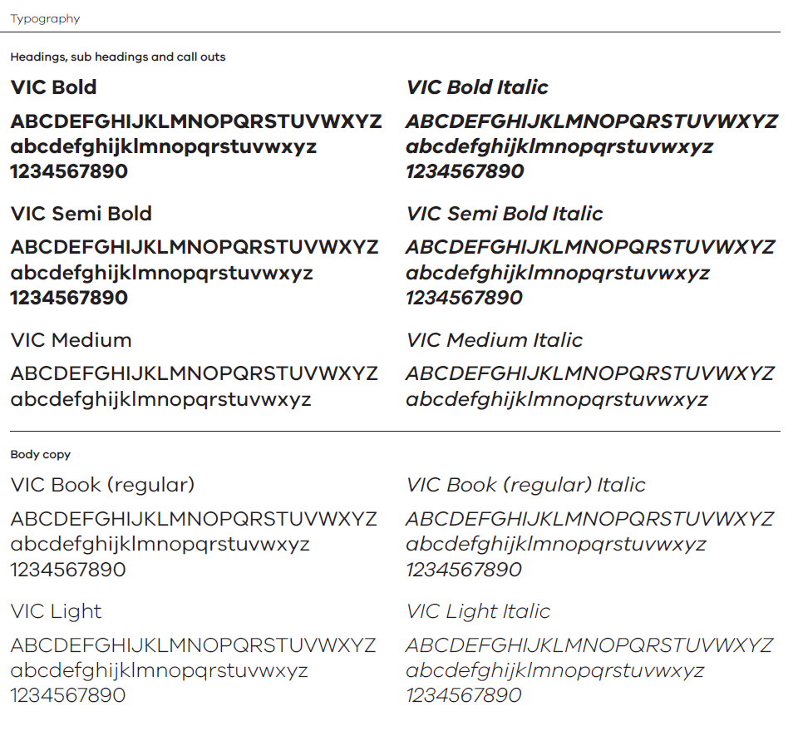

Alternative font
Where VIC isn’t available, for example on-screen presentations or internal Microsoft Office templates, then Arial should be used to replace VIC font and Times New Roman to replace Chronicle Display. Both alternative fonts should be used as intended when VIC font or Chronicle is not available.
- Arial Black – Suitable for uses such as print and advertising headlines, brochure titles.
- Arial Bold – Suitable for uses such as brochure titles, major headings, subheadings to body copy.
- Arial Bold Italic – Suitable for uses such as highlighting or differentiating small areas of body text, but must not be used for continuous passages of body text for legibility reasons.
- Arial Regular – Suitable for uses such as large amounts of body copy.
- Arial Italic – Suitable for uses such as highlighting or differentiating small areas of body text, but must not be used for continuous passages of body text for legibility reasons.
Examples of Arial font below:
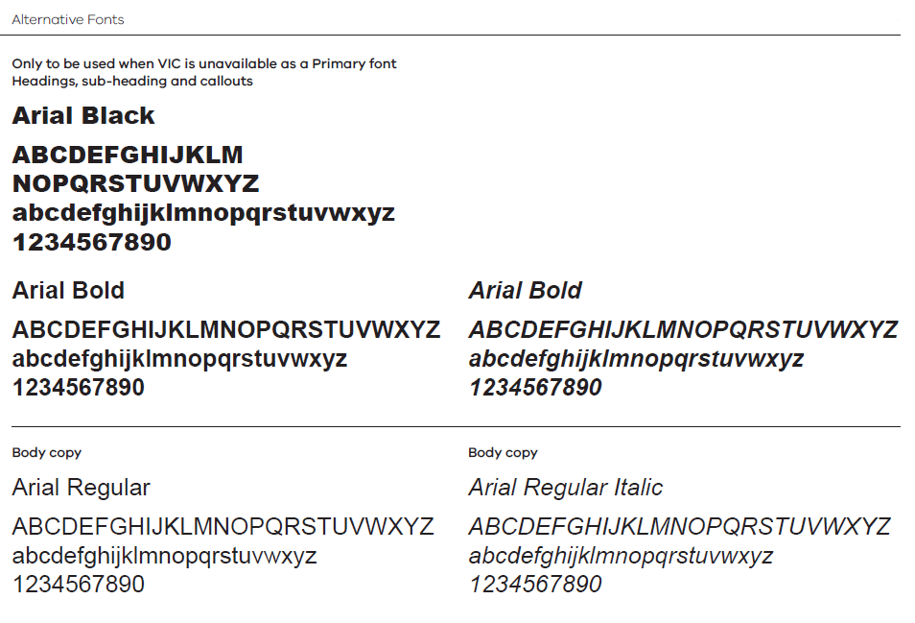

Colour palette
The colours used in this years’ festival are the same as in 2025 and use four vibrant gradations. The gradations should blend evenly from light tone at top to darker tone at bottom. Download colours from Dropbox.

The background colours should only be used in combination with black text and logos for legibility.
The colours meet AAA contrast accessibility when used with black text.
Purple gradation |  |  | Orange gradation
 | R: 255  G: 185  B: 227  HEX: ffb9e3 | C: 0  M: 33  Y: 0  K:0 |  | R: 255  G: 215  B: 0  HEX: ffd700 | C: 0  M: 13  Y: 100  K: 0
 | R: 227  G: 95  B: 231  HEX: e35fe7 | C: 25  M: 0  Y: 0  K: 0 |  | R: 255  G: 100  B: 10  HEX: ff640a | C: 0  M: 75  Y: 100  K: 0
Green gradation |  |  | Blue gradation
 | R: 174  G: 255  B: 135  HEX: aeff87 | C: 32  M: 0  Y: 67  K: 0 |  | R: 167  G: 234  B: 255  HEX: a7eaff | C: 30  M: 0  Y: 0  K: 0
 | R: 41  G: 194  B: 88  HEX: 29c258 | C: 72  M: 0  Y: 89  K: 0 |  | R: 97  G: 149  B: 238  HEX: 6195ee | C: 60  M: 37  Y: 0  K: 0

QR Code
Use this QR code on your printed publications to guide people to the festival website. Aim to print it at minimum 25mm so it is accessible. Download QR code from Dropbox.
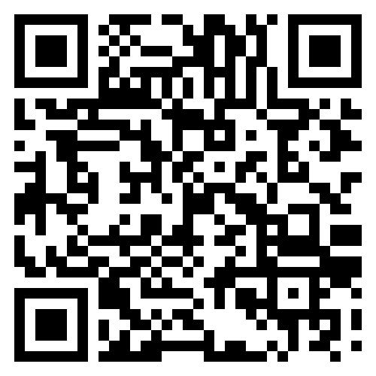

Photography
The overall tone of the photography is upbeat and positive. The colour portraits really accentuate the vibrancy and excitement of the festival. Representatives from our diverse community were selected to communicate the theme of this year’s festival, Connect, Create, Celebrate. We have 6 portraits for use in 2026.

Conditions of use
We appreciate the support of the 6 seniors pictured in helping to promote the fun and joy of the festival.
Stakeholders may only use photos of the ambassadors shown in this year’s toolkit.
High resolution images are available via Dropbox to support your event promotions.
Any materials created with these images must be approved in writing, by the Department of Families, Fairness and Housing, prior to publishing in any form.
- Please contact the Seniors Festival team with an example of the portrait in use with your brand elements added. Approvals can be requested by email at seniorsfestival@dffh.vic.gov.au
- Image consent only extends to use of these images for 2026 Victorian Seniors Festival purposes.
- These images must be used with the 2026 Victorian Seniors Festival branding including the festival brandmark and Victorian State Government logo.
- These images cannot be used for any other purposes.
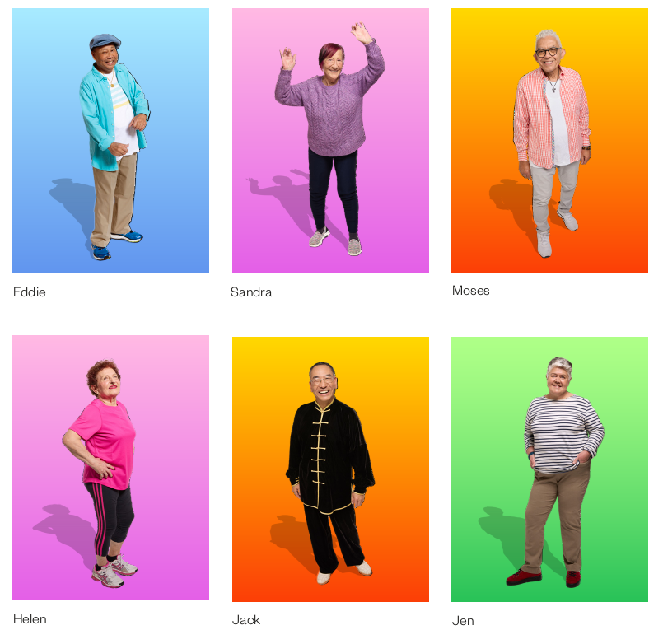

Digital assets
Digital assets have been created to help you promote your events as a part of the Victorian Seniors Festival. There are also promotional posters you could print to place on noticeboards and community access points.

Newsletter banners
Banners are available in a variety of dimensions and colours to support digital communications.
Download newsletter banners from Dropbox.
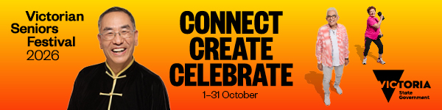
- eNews – 1080x1080px – 2026 VSF
- eNews – 600x500px – 2026 VSF
- eNews – 600x275px – 2026 VSF
- eNews – 600x250px – 2026 VSF
- eNews – 600x150px – 2026 VSF

Web banners
Web banners featuring the 2026 Victorian Seniors Festival ambassadors are available in a variety of dimensions and colours.
Download web banners from Dropbox.
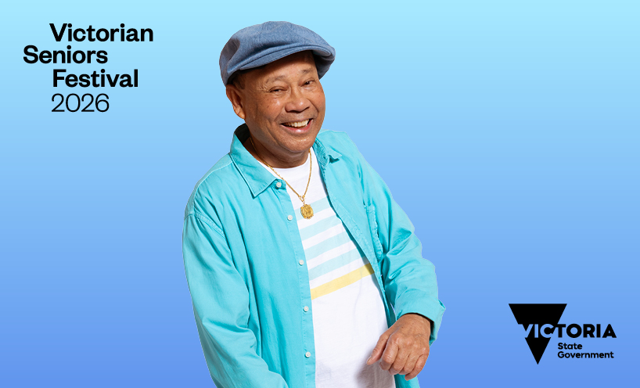
- Web banner – 1280x720px – 2026 VSF
- Web banner – 818x496px – 2026 VSF
- Web banner – 752x487px – 2026 VSF
- Web banner – 733x260px – 2026 VSF

Social media tiles
A range of social media tiles are available featuring the 2026 Victorian Seniors Festival ambassadors including:
- 1080x1080px, blue, green, orange and purple social media tiles
- 1080x1350px, blue, green, orange and purple social media tiles
- 1080x1920px, blue, green, orange and purple social media tiles are available with 3 ambassadors and 1 ambassador
Download social media tiles from Dropbox.
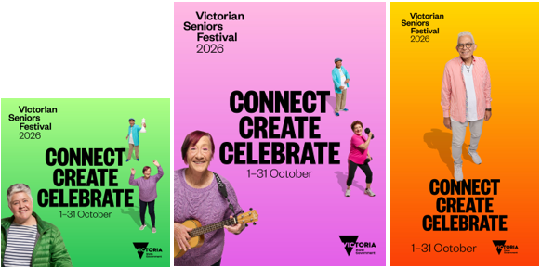

Print assets

A4 headers
A4 headers combine images of brand ambassadors, brandmark and tagline. A4 headers are available in all 4 colours.
A4 headers – download A4 headers from Dropbox.

Posters

General promotional posters
We have created 4 posters in A4 size and A3 size for you to print out and put up or share with stakeholders or your community. One set feature 4 ambassadors, and the other set has 3 ambassadors.
Download promotional posters from Dropbox.
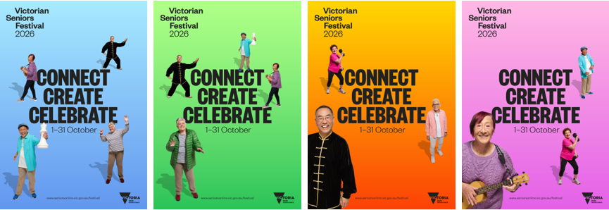

A4 size poster set
Download A4 poster set from Dropbox.

A3 size poster set
Download A3 poster set from Dropbox.
Contact us to receive this document in another format. Please phone the Victorian Seniors Festival team on (03) 8850 6164 or email seniorsfestival@dffh.vic.gov.au.
If you are d/Deaf, hard of hearing, or have a speech/communication difficulty please contact us through your preferred National Relay Service (NRS) call channel Then, provide the NRS with our phone number (03) 8850 6164. For more information, visit About the National Relay Service
Authorised and published by the Victorian Government, 1 Treasury Place, Melbourne.
© State of Victoria, Australia, Department of Families, Fairness and Housing, May 2026.

https://www.accesshub.gov.au/about-the-nrs/nrs-call-numbers-and-links
https://www.accesshub.gov.au/about-the-nrs

