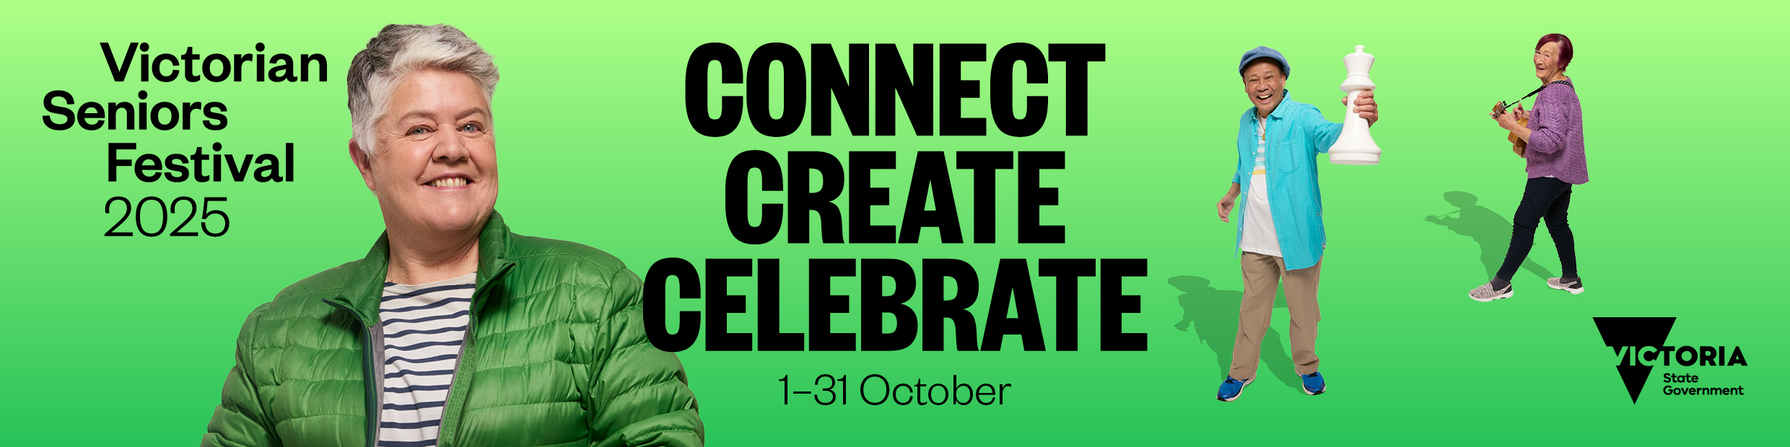

How to guide for the Victorian Seniors Festival online event calendar
OFFICIAL
Contents
Overview 1
Key dates 1
New features 2
Event criteria 2
Submitting an event 3
Creating an event submission 3
After event submission 11
Making changes to your event 11
Submit an image for your event page 11
Victorian Seniors Festival design assets 11
Contact 11

Overview
The online event calendar is hosted on Seniors Online and promotes thousands of Victorian Seniors Festival events that occur between 1 – 31 October.

Key dates
Activity | Date | Time
Online event calendar opens for submission | Thursday 3 July | 2:00 pm
Online event calendar closes for submission | Sunday 17 August 2025 | Midnight
Event submission changes request deadline | Friday 22 August 2025 | 5:00 pm
Online event calendar launched on Seniors Online | Tuesday 2 September 2025 | By 5:00pm

New features
New features have been added to the event submission form and calendar this year, to improve the experience for event submitters and calendar users.

The new features that support you as an event submitter include:
- Ability to submit one event form to cover multiple event dates and times
- Reordering of the form to make it clearer which information will be published and available publicly
- Back-end stability enhancements to cope with the ongoing growth in the quantity of events submitted

The new features that support calendar users when the calendar goes live include:
- Map view option for event attendees, enabling them to see all events in a visual format in addition to the pre-existing list view
- Multiple event dates listed on events, where applicable, rather than having to search through multiple event pages individually
- Favourites function to create a personalised list of events that calendar users are interested in, when reading individual event pages.

  - Once events have are added to favourites, a dialogue box appears to ‘view favourites’ and this feature allows calendar users to capture up to 10 ‘favourites’ in this grouping.

Event criteria
Before you submit your event, please note the following criteria, to ensure your event can be listed.
Special offers and discounts for older Victorians will not be accepted as an event submission. Information on providing offers and discounts by joining the Victorian Seniors Card program is available on Seniors Online.

Events must:
- take place in October 2025
- be free or low cost
- offer good quality entertainment in a friendly, inclusive environment
- offer people an opportunity to try something new.

Incomplete forms, or submissions provided in capital letters, are not eligible for publishing.
The Department of Families, Fairness and Housing reserves the right to edit or decline any submitted event.

Submitting an event
Our online event calendar is now open for submissions on Seniors Online
The calendar will close for submissions at midnight on Sunday 17 August. No extensions will be available past this deadline due to the volume of events that require processing before publication.

Creating an event submission
This year we have revised the order of the form and added some extra functionality to make creating events and adding multiple events even easier.
Head to Seniors Online or https://seniorsonline.vic.gov.au/victorian-seniors-festival-event-submission to open the event submission form.

Step 1: Event contact information
This field asks for the contact information that event attendees will use to arrange bookings or ask questions. This information will feature on the online event calendar and be made publicly available.
For this section you will need:
- Contact name
- Contact phone number - enter ten-digit number without spaces. e.g.1300123456
- Contact email
- Event website – please ensure your event website is live prior to 9:00 am, Tuesday 2 September 2025

Step 2: Event information
- Event name - please make specific/not just Seniors Festival Open Day
- Event type - in person/online
- Event category - select the category that best fits: e.g. Body & Soul

Step 3: Add date and time
- Start date
- Start time - required format hh:mm, where hh is hour, mm is minutes, 24 hr format
- End date
- End time - format as above

Step 3.1: Add more dates
If your event occurs on multiple occasions, you can now provide this information in a single event submission.
Once you have included the date and start/end time for the first occurrence of your event you will be offered ‘Add more dates’ option.
If you check the box to confirm yes, another prompt will ask: How many more dates do you want to add?
You can add a minimum of 1 more date/time or a maximum of 15 extra dates/times, this covers:
- an event occurring on the same day, but at different times - Example 1
- an event occurring on different days and at times - Example 2
- an event occurring on different days but at the same time - Example 3

Example 1: An event occurring on the one day, but at different times
Cooking class that runs on 1 October at 10:00 am, 12:00 pm and at 3:00 pm.
Example 1, step 1: Enter the first occurrence of the event – in this case it would be 1 October at 10:00 am. We are assuming the session runs for 1 hour so ends at 11:00 am.
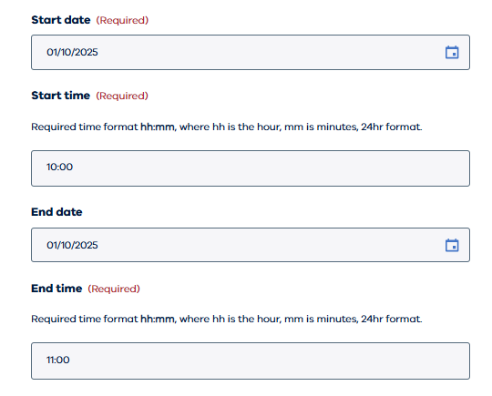
Example 1, step 2: Tick the box to confirm your event has more dates
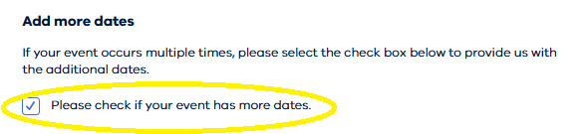
Example 1, step 3: Enter the quantity of additional sessions that are running on that date.
- In our example here that would be 2, as the session is already listed for 10:00 am, so we need to complete the information for the 12:00 pm and 3:00 pm session.
- Extra fields will appear on your screen for these 2 sessions to be included.
- Don’t forget the form is set-in 24-hour time!
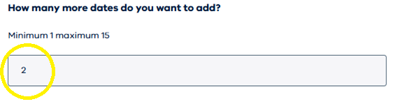

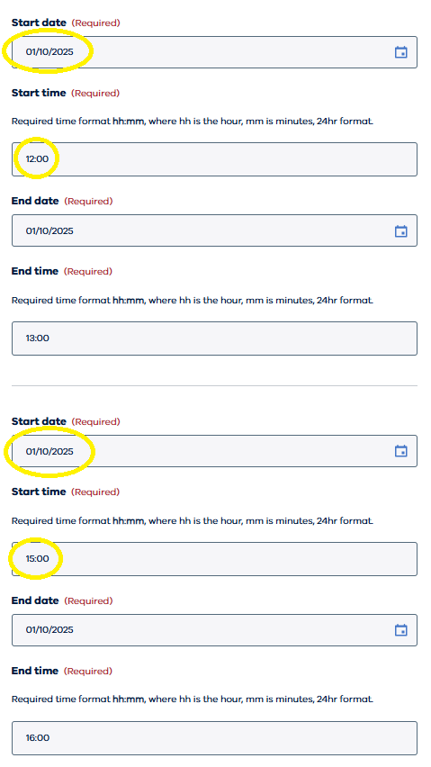

Example 2: An event occurring on different days and at different times
Art class that runs on 5 October at 10:00 am, 8 October at 11:00 am and 16 October at 2:00 pm.
Example 2, step 1: Enter the first occurrence of the event – in this case it would be 5 October at 10:00 am. We are assuming the session runs for 1 hour so ends at 11:00 am.
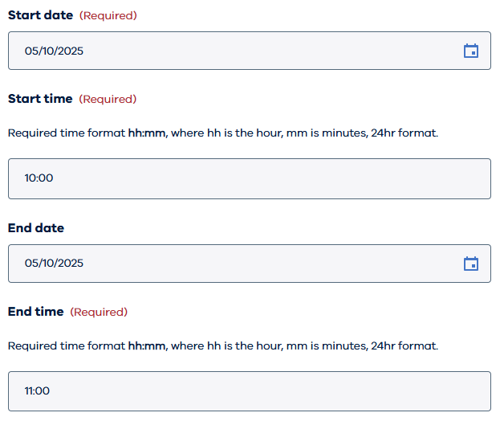
Example 2, step 2: Tick the box to confirm your event has more dates
Example 2, step 3: Enter the quantity of additional sessions that are running on that date
- In our example here that would be 2, as the session is already listed for 10:00 am, so we need to complete the information for the 11:00 am and 2:00 pm session.
- Extra fields will appear on your screen for these 2 sessions to be included.
- Don’t forget the form is set-in 24-hour time!
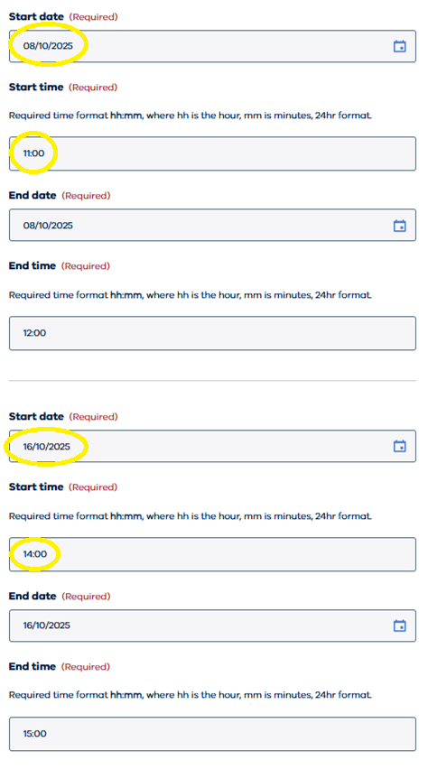

Example 3: An event occurring on different days but at the same time
Technology skills class that runs every day in the first week of October at 10:00 am.
Example 3, step 1: Enter the first occurrence of the event – in this case it would be 6 October at 10:00 am. We are assuming the session runs for 1 hour so ends at 11:00 am.
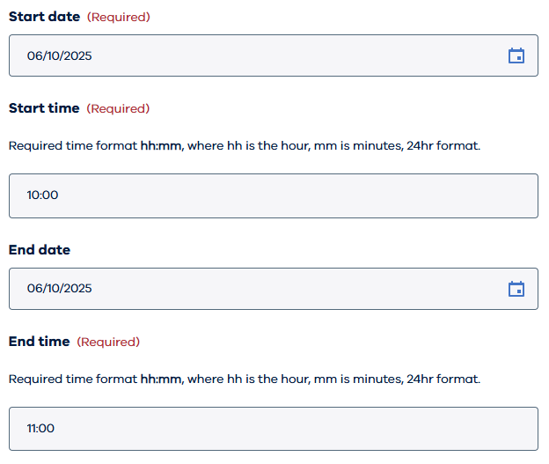
Example 3, step 2: Tick the box to confirm your event has more dates.
Example 3, step 3: Enter the quantity of additional sessions that are running on that date.
- In our example here that would be 6 more, as the session is already listed for 6 October at 10:00 am so we need to complete the information for 7, 8, 9, 10, 11 and 12 October at 10:00 am.
- Extra fields will appear on your screen for these 6 sessions to be included.
- Don’t forget the form is set-in 24-hour time!
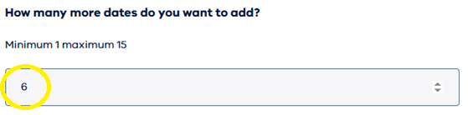

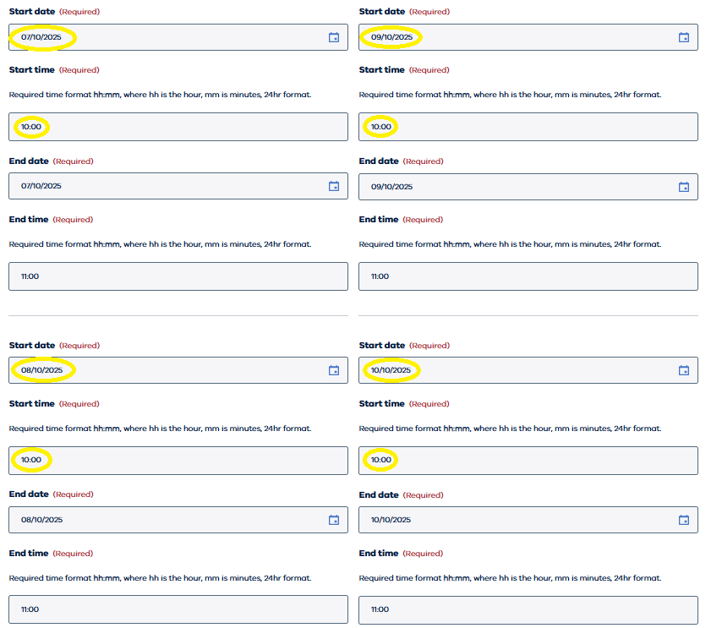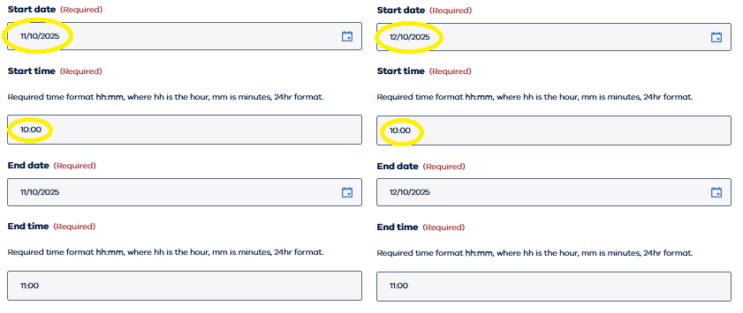

Step 4: Short event description
This is a promotional blurb that appears on the list and map view with the event. e.g. ‘Keep fit and build strength while socialising’. The character limit is 100.

Step 5: Long event description
This is the detailed description that will show on the individual for the event page. This may include what attendees can expect, who is performing, booking deadlines, and what to bring.

Step 6: Venue address
This year our online event calendar includes a map feature so providing specific information here is critical in supporting the promotion of your event. Make sure you include the building name (e.g. Town Hall) and street number means your audience can see the exact location for your event on a map within a town/suburb, with your calendar listing.
This is a required field for all in person events.
For this section you will need:
- Street address e.g. Melbourne Town Hall
- Street address line 2 e.g. 27 Fisher Street
- Suburb
- State
- Postcode

Step 7: Cost
Victorian Seniors Festival events are required to be free or low cost.
The options available in the form include:
- Free
- Gold coin donation
- Dollar amount of the entry ticket

Step 8: Inclusions
Enter any event inclusions and details about whether your event is accessible (e.g. Morning tea starts at 10:00 am and is included in the ticket price. This event is accessible for people with disability.)

Step 9: About you
Information provided here is so we can contact you, if we need to check event detail prior to publishing. This information is not published on your event listing or made publicly available.
For this section you will need:
- First name
- Last name
- Title
- Organisation
- Contact email address
- Confirm email address
- Phone number - enter ten-digit number without spaces e.g. 1300123456

Step 10: Submit your event
Once you have completed all the information, and checked everything included is correct, click the submit button shown.

After event submission
After you click submit you can either proceed with completing another event submission for events you are hosting or close the window to exit.
You will automatically receive a confirmation email to the address entered in the about you section, which includes:
- A summary of all the information you have provided, exactly as submitted
- An event submission number: e.g. #3229

Making changes to your event
If you notice any errors in your event details, after you have reviewed the confirmation email, please reach out to the festival team quoting your event submission number clearly on seniorsfestival@dffh.vic.gov.au.
Changes can be requested until 5:00 pm, Friday 22 August 2025.
Any requests made following this deadline are not guaranteed and will be actioned according to priority.

Submit an image for your event page
If you would like to include an image for your event, please forward the image file to the Seniors Festival Team on seniorsfestival@dffh.vic.gov.au with reference to your event name submission number in the subject line.
The image must:
- be 580px wide x 340px high
- be supplied as a .jpg or .png file
- not include any text or booking information. For example, it cannot be a promotional poster.
Please ensure you have consent and copyright to share any images supplied.

Victorian Seniors Festival design assets
Festival design assets are available to support you to promote your event to the community. For a copy of the promotional toolkit, please email the Seniors Festival Team on seniorsfestival@dffh.vic.gov.au.

Contact
If you have any queries or questions, please contact the festival team on seniorsfestival@dffh.vic.gov.au.
To receive this document in another format, phone (03) 8850 6164, using the National Relay Service 13 36 77 if required, or email the Seniors Festival Team <seniorsfestival@dffh.vic.gov.au>.
Authorised and published by the Victorian Government, 1 Treasury Place, Melbourne.
© State of Victoria, Australia, Department of Families, Fairness and Housing, June 2025.

